Graded Unit- Power House Gym User Guide part 2

Krzysztof Stepien

Table of Contents

1. Admin Guide 3

1.1 Logging in 3

1.2 Management Centre – manage personal trainers 4

1.3 Management Centre- manage user. 6

2. Personal Trainer 7

2.1 Logging in 7

2.2 Management Centre – my details 8

# Admin Guide

### 1.1 Logging in

First step to access the admin panel is to log in to the website. It can be done by navigating to the Log in page of the system and entering the admin log in data into the input boxes.

Email: [admin@admin.gov](mailto:admin@admin.gov)

Password : admin

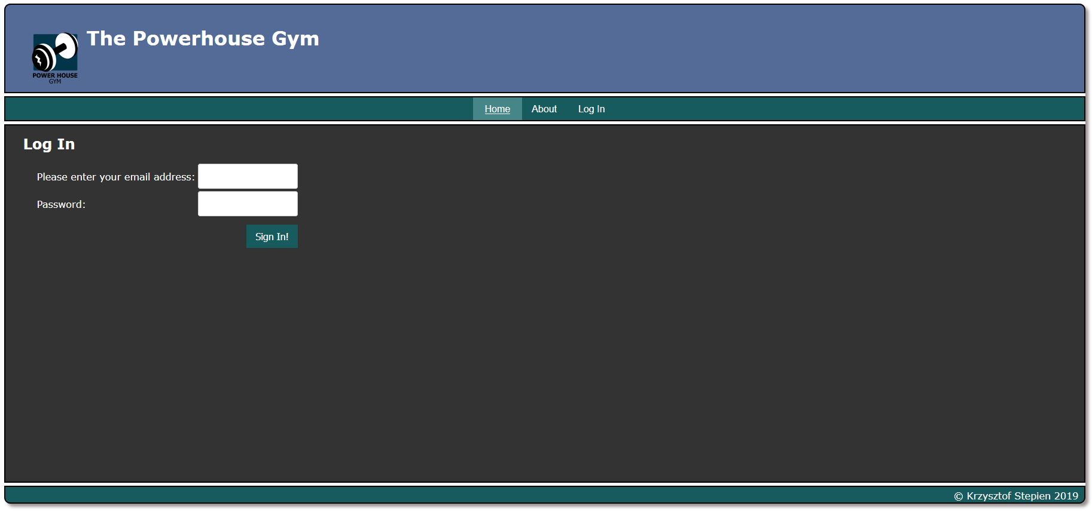

After logging in the admin is redirected back to main page, but now have access to additional options – Management Centre and Sign out. 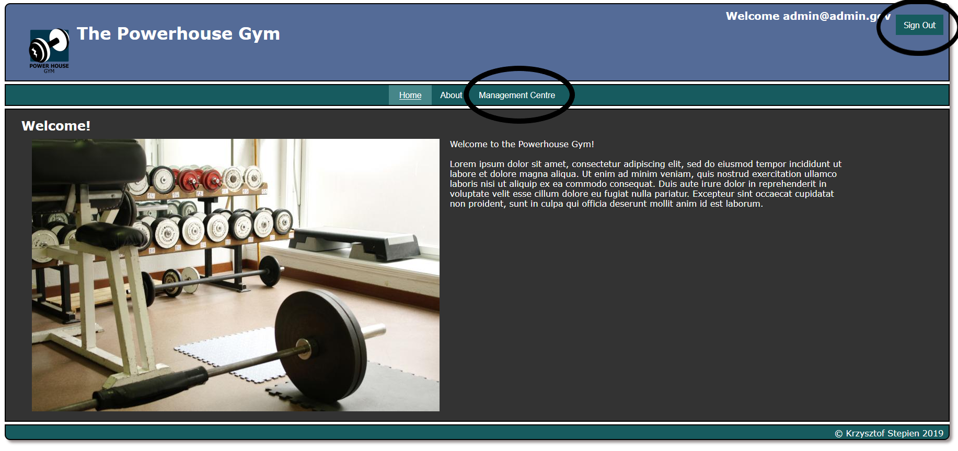

### 1.2 management Centre – MAnage personal trainers

After hovering on the Management Centre admin is presented with the submenu and have an option to Manage Personal Trainers or Manage User Details

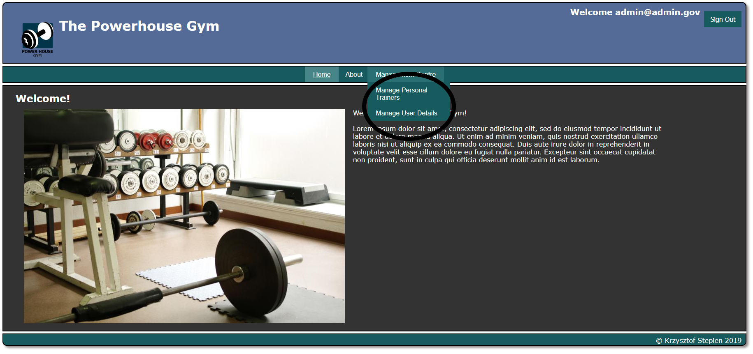

After clicking the Manage Personal Trainers tab, the list of all the personal trainers in the system is displayed with their details. This page allows to Add the new personal trainer, Edit the personal trainer details or delete the personal trainer from the database.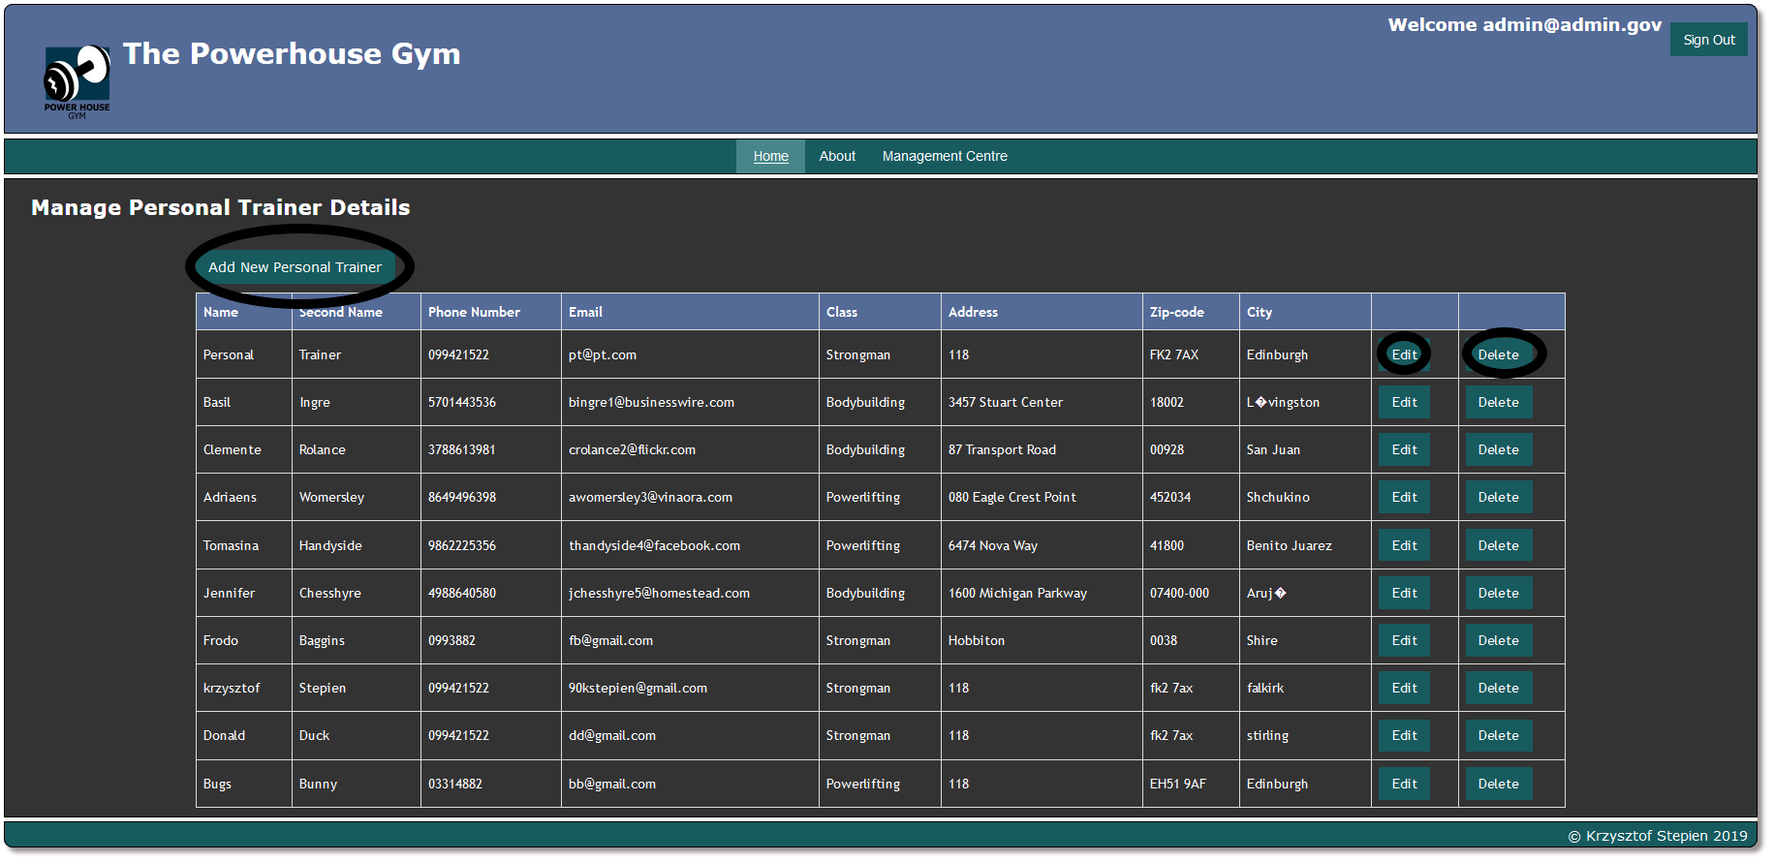

Adding the new personal trainer and edit buttons take the administrator to the form page that allow to input the new data. Admin should input the necessary data and press the Submit button located in the bottom right of the page. Those 2 pages share their functionality, the only difference is that new personal trainer form creates the new entry in the database, updating the entry allows to change the already existing users details.

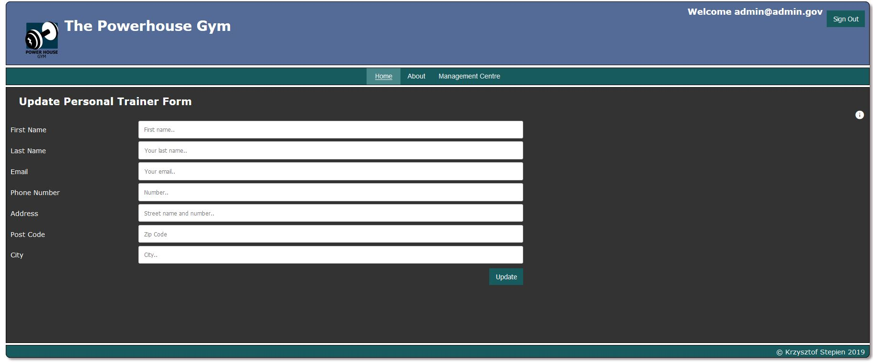

In the right corner of the page there is a little ‘i’ icon, which on hover will display the tooltips helping to input the data.

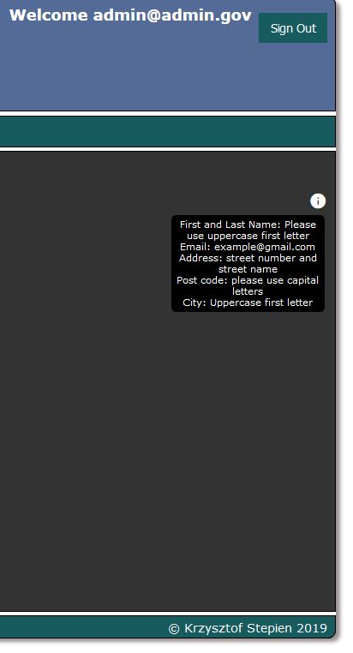

### 1.3 Management Centre- manage user.

Manage user details allows admin to access the data of the gym customers. This page shares some of the functionality with the personal trainer functionality, adding new user, editing the details and deleting the user is the same as in personal trainer case. Difference is in addition of More… button which allows the admin to preview additional details of the customer. 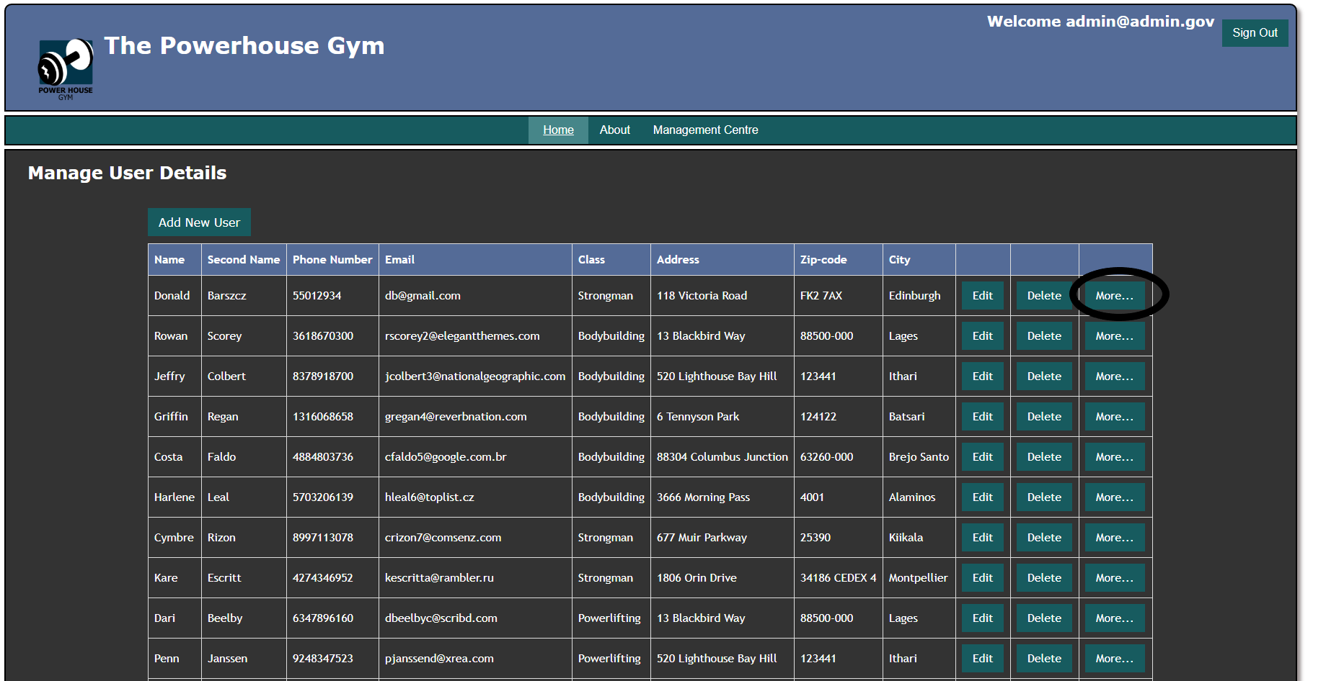

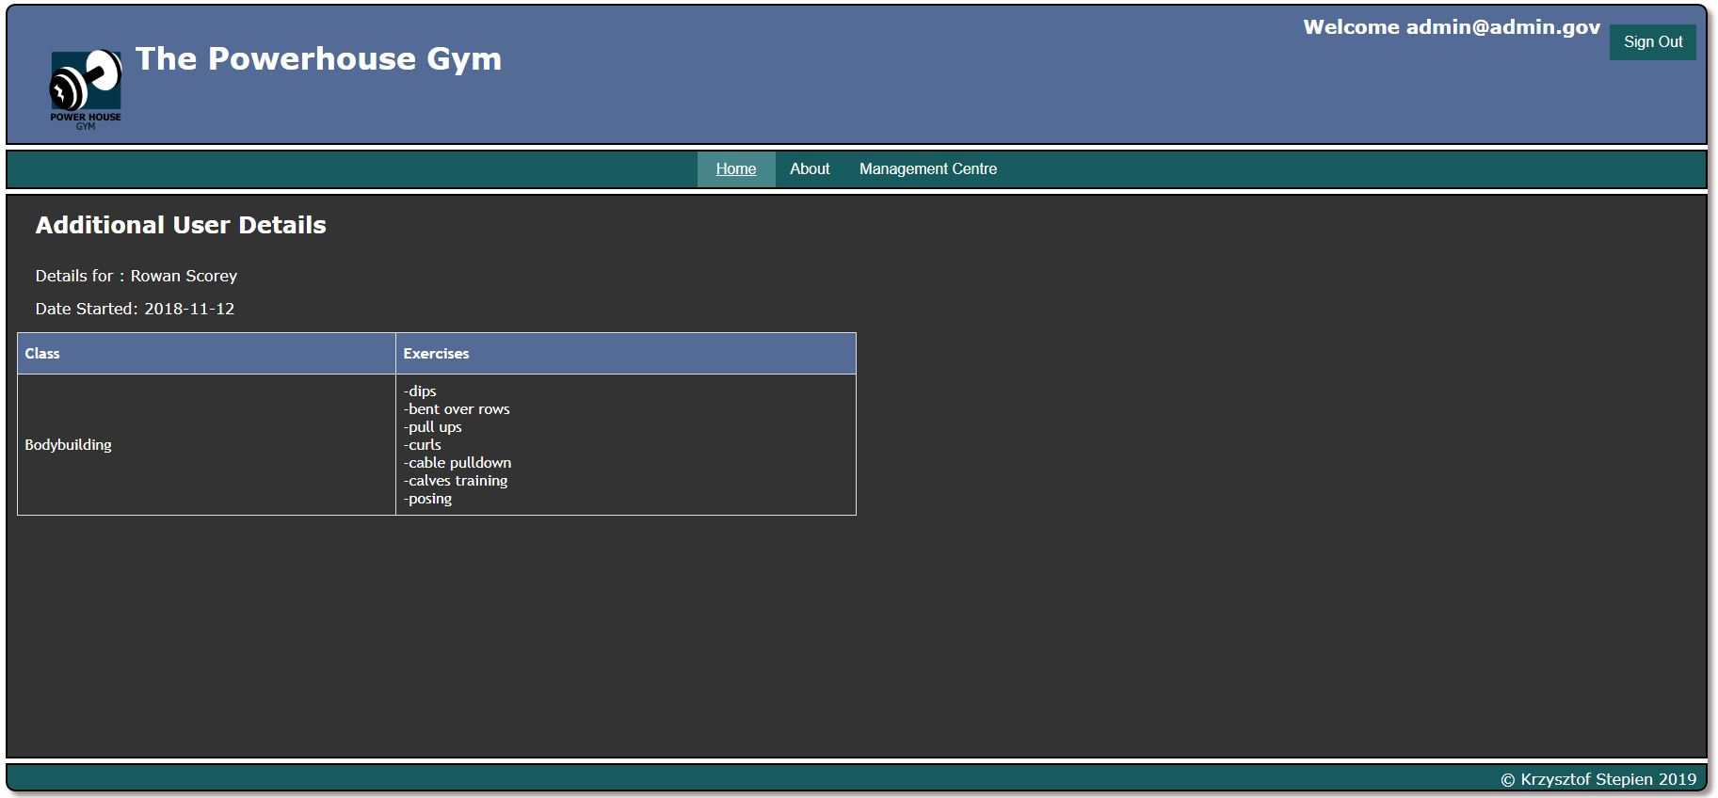

If the admin is ready to finish his work , the Sign out button in the top right corner of the page will allow to sign out.

# Personal Trainer

### Logging in

Personal trainer logging in details can be created by the administrator of the system. For the testing purposes I have prepared the username and password for the personal trainer:

Login: [pt@pt.com](mailto:pt@pt.com)

Password : pt

After logging in personal trainer is presented with a little different menu:

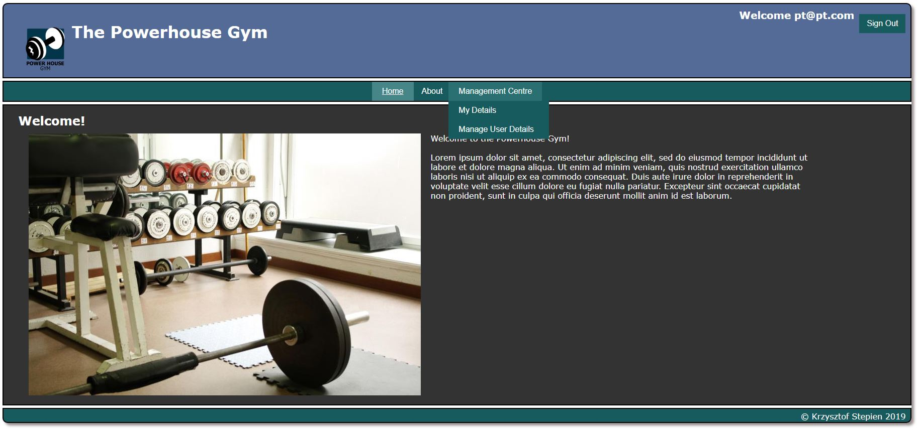

Personal trainer have access to the My Details page and Manage user details page. Manage user details functionality is shared between admin and personal trainer and the functions are the same like in the previous section of this document.

### Management Centre – my details

My details page allows the personal trainer to display the data for the logged in personal trainer only, also allowing to change those details by clicking the edit button:

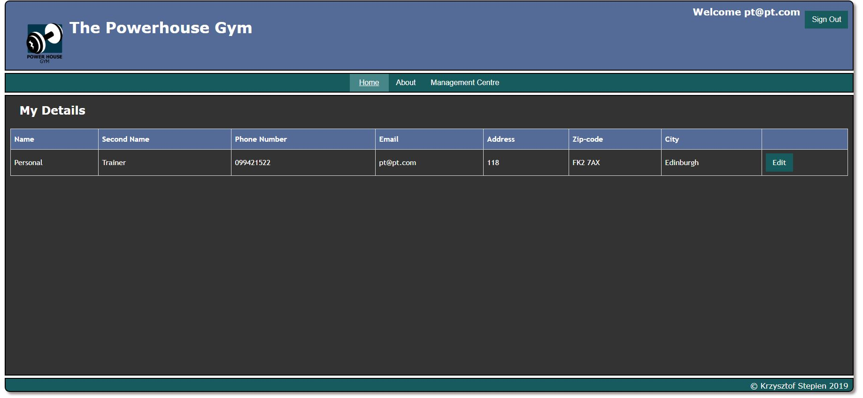

And finally the form allowing to change the PT data: 